INFOSYS SPRINGBOARD
VIRTUAL INTERNSHIP 7.0
MedTrack DV
Hospital Operations & Patient Analytics Dashboard
Final Project Report

Submitted by
Shakshi Singh
Internship Program
Infosys Springboard Virtual Internship 7.0
Tools: Python (Pandas, NumPy) | Tableau Desktop / Public

1. Project Statement
MedTrack DV is a comprehensive Hospital Operations & Patient Analytics Dashboard suite developed to analyze hospital performance, patient admissions, department efficiency, and healthcare resource utilization. The project transforms raw hospital operational data into actionable insights through interactive Tableau dashboards, helping hospital administrators, healthcare managers, medical staff, and policymakers monitor patient flow, evaluate department performance, and make data-driven decisions.
The final deliverable is a unified Tableau workbook consisting of four interconnected dashboards — Hospital Overview, Patient Flow, Department Analysis, and Resource Utilization — built on top of a cleaned and feature-engineered patient dataset processed using Python and Pandas.

2. Tools & Technologies
Area | Tools / Libraries
Programming Language | Python 3
Data Processing | Pandas, NumPy
Development Environment | Jupyter Notebook
Visualization | Tableau Desktop / Tableau Public
Documentation | Markdown

3. Dataset Overview
The raw dataset (hospital_patient_analytics_expanded.csv) contains 15,000 patient records across 12 columns, including Patient ID, Patient Name, Age, Gender, City, Department, Doctor Name, Admission Date, Discharge Date, Insurance Provider, Bill Amount, and Patient Satisfaction Score.
Metric | Value
Total Raw Records | 15,000
Total Raw Columns | 12
Final Cleaned Records | 14,734
Final Columns (after feature engineering) | 20

4. Data Cleaning & Preprocessing

4.1 Gender Standardization
The Gender column originally contained highly inconsistent values such as M, m, Male, MALE, F, f, Female, FEMALE, O, Other and other. These were standardized using string normalization (lower-casing and trimming) and mapped into consistent Male and Female categories, significantly improving data consistency for downstream analysis.

4.2 Missing Value Treatment
A missing value audit revealed gaps in five columns:
Column | Missing Values | Missing %
Insurance_Provider | 1,878 | 12.52%
Patient_Satisfaction_Score | 1,002 | 6.68%
Age | 450 | 3.00%
Discharge_Date | 375 | 2.50%
City | 300 | 2.00%

- Age — missing values imputed using the column median.
- City — missing values imputed using the most frequent value (mode).
- Insurance_Provider — missing values filled with the category “None”.
- Patient_Satisfaction_Score — missing values imputed using the column median.
- Discharge_Date — missing values filled using the corresponding Admission_Date.

4.3 Invalid Records & Duplicates
- Removed all records with negative Bill_Amount_INR values.
- Removed duplicate patient records based on Patient_ID.
- Removed records where Length_of_Stay computed as negative (Discharge_Date earlier than Admission_Date).
After these cleaning steps, the dataset was reduced from 15,000 to 14,734 valid, high-quality records with zero remaining missing values across all columns.

5. Feature Engineering
To support richer analytical capability in Tableau, several new features were engineered from the cleaned dataset:
- Length_of_Stay — calculated as the number of days between Discharge_Date and Admission_Date.
- Admission_Year, Admission_Month, Admission_Quarter, Admission_Day — extracted from Admission_Date for time-based trend analysis.
- Age_Group — categorical bins: 0–18, 19–35, 36–50, 51–65, 65+.
- Bill_Category — categorical bins based on Bill_Amount_INR: Low, Medium, High, Very High.
- Stay_Category — categorical bins based on Length_of_Stay: Same Day, 1–3 Days, 4–7 Days, More than 7 Days.
The final cleaned and enriched dataset was exported as hospital_operations_patient_analytics_cleaned.csv, ready for use as the data source for all four Tableau dashboards.

6. Key Dataset Insights
- Department distribution is fairly balanced, with General Medicine recording the highest number of patients (1,284) and ENT the lowest (1,202).
- Total Admissions in the cleaned dataset stand at 14,734, generating a Total Revenue of ₹1,48,83,76,190.
- The Average Bill per patient is ₹1,01,016 with an average patient satisfaction score of 4 (on the applicable scale).
- The majority of stays fall into the 1–3 Days category (5,978 patients), followed by Same Day (3,821) and 4–7 Days (2,998).
- Gender split across admissions is close to even, with a slightly higher share of female patients.

7. Dashboard Suite (Tableau)
The MedTrack DV workbook consists of four interconnected, filter-linked dashboards, each focused on a specific operational lens. All dashboards share common filters (Admission Year, City, Gender, Department) and are connected through navigation buttons for seamless drill-down analysis.

7.1 Hospital Overview
Provides a top-level summary of hospital performance including Average Bill, Average Patient Satisfaction Score, Total Admissions, and Total Revenue. It breaks down admissions by stay category, department-wise satisfaction and revenue, monthly admission trends, gender split, and insurance provider distribution.
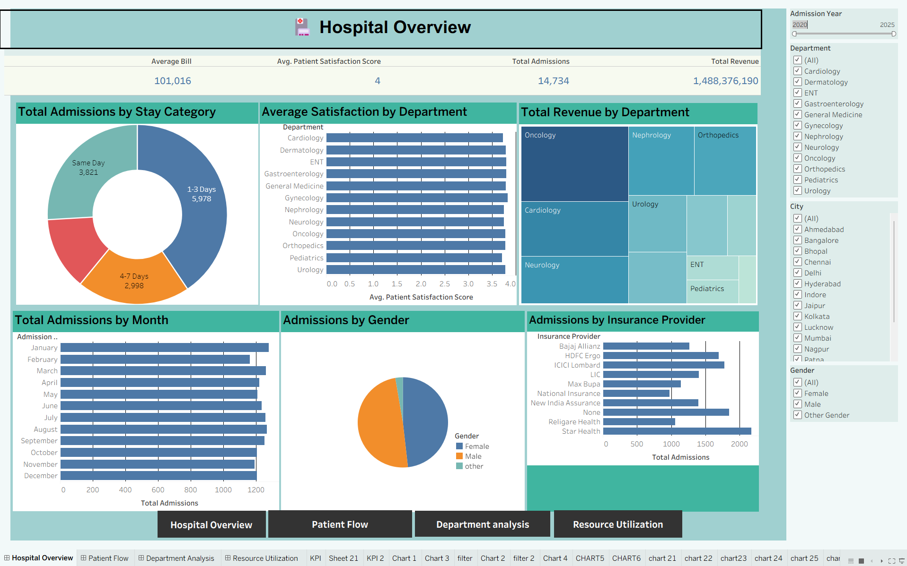
Fig 1: Hospital Overview Dashboard

7.2 Patient Flow
Focuses on how patients move through the hospital over time — monthly admission trends, day-of-week admission patterns, discharge trends, length-of-stay categories, gender distribution, and insurance provider mix, enabling capacity and staffing planning.
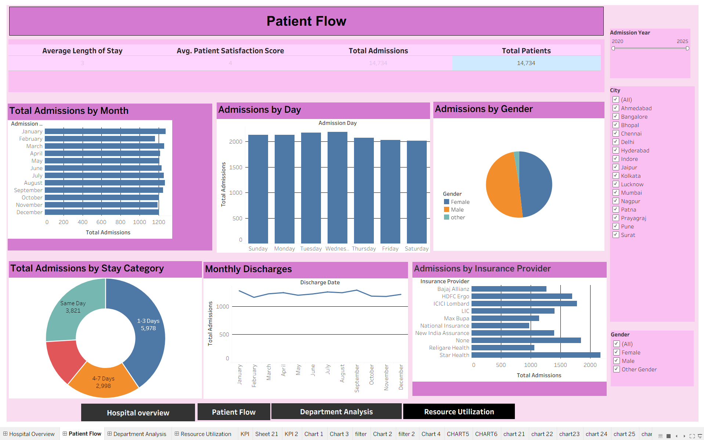
Fig 2: Patient Flow Dashboard

7.3 Department Analysis
Compares departments on revenue contribution, admission share, average patient satisfaction, and the relationship between revenue and average bill. A scatter plot of satisfaction versus average length of stay (sized by total patients) highlights department-level performance trade-offs. Oncology leads in revenue contribution (₹28.9 crore), followed by Cardiology and Neurology.
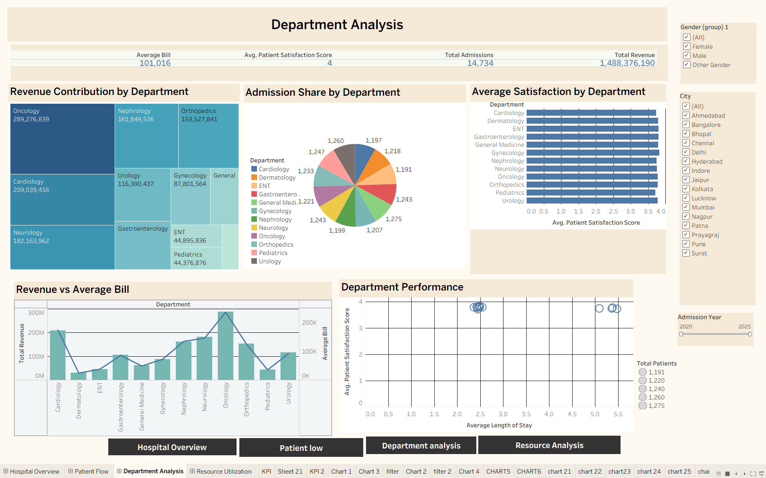
Fig 3: Department Analysis Dashboard

7.4 Resource Utilization
Tracks hospital resource efficiency — Total Doctors (27), Total Patients (14,734), Average Length of Stay, and Patients per Doctor (546). Visualizes patients-per-doctor by department, patient volume by department, average length of stay trends, department performance, and the distribution of patient satisfaction scores, helping identify departments that may be over- or under-resourced.
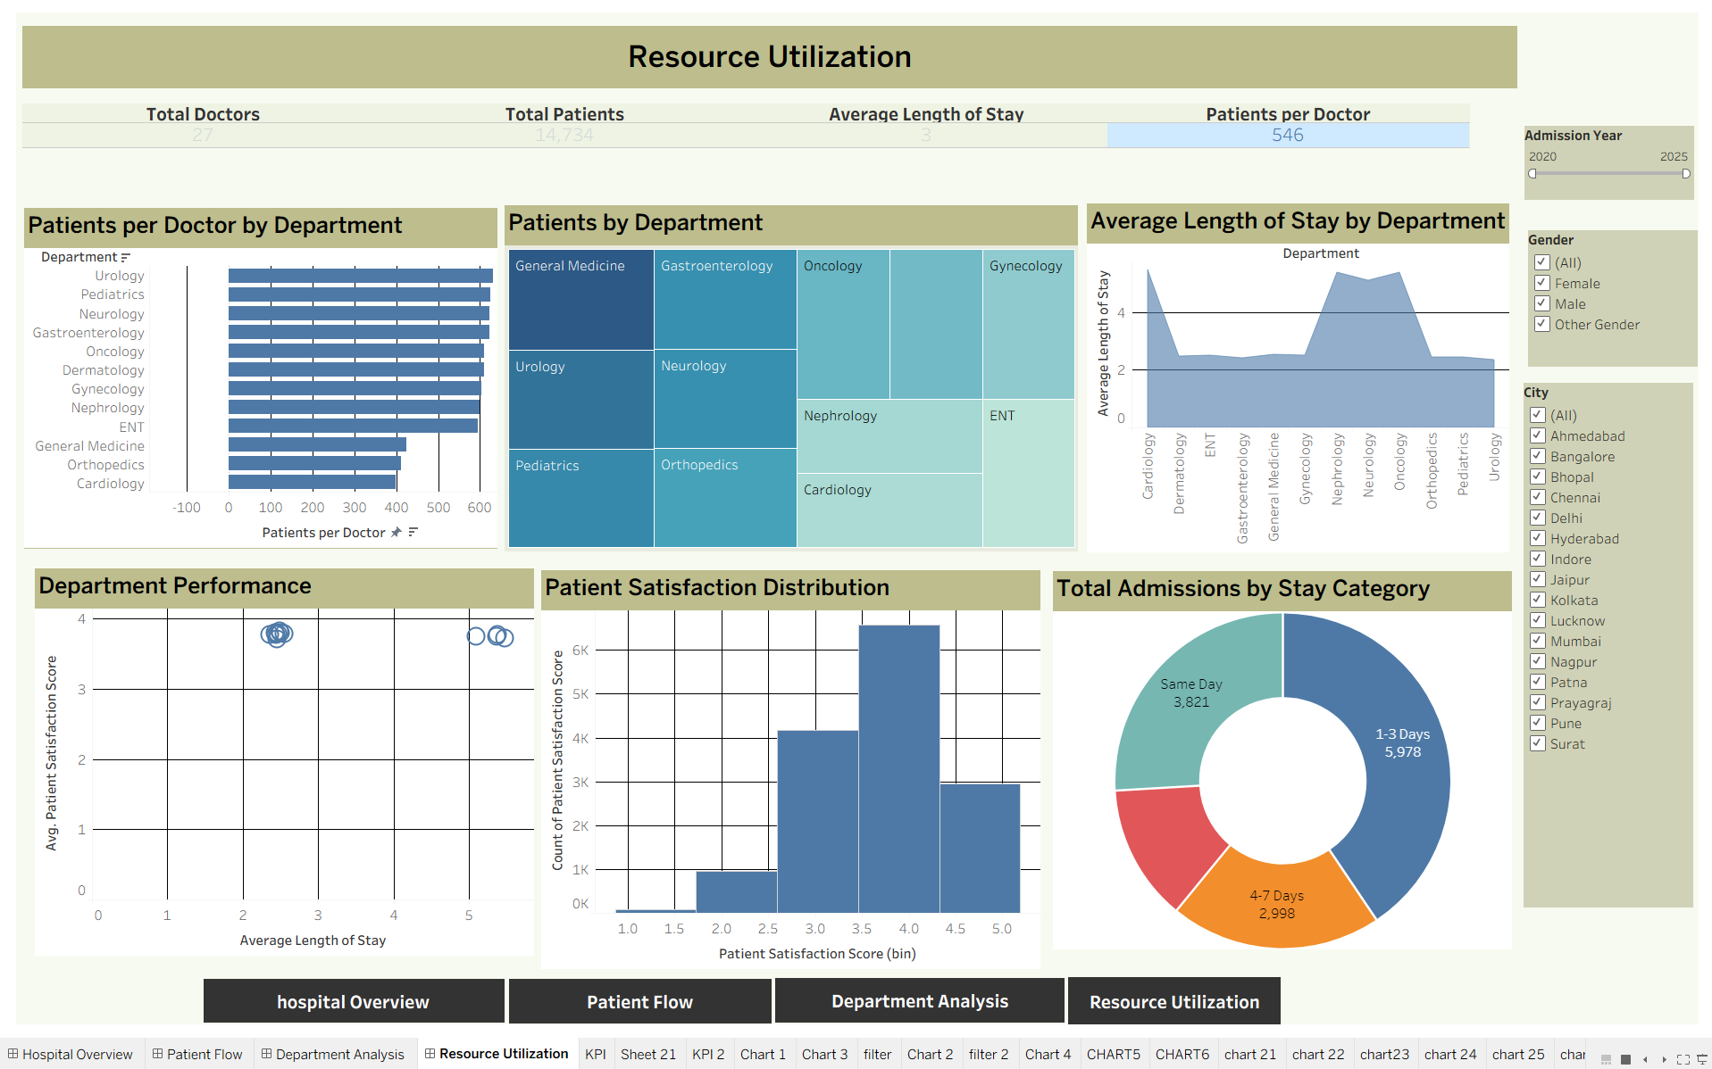
Fig 4: Resource Utilization Dashboard

8. Conclusion
The MedTrack DV project successfully demonstrates an end-to-end healthcare analytics workflow — from raw, inconsistent hospital data to a clean, feature-rich dataset, and finally to a fully interactive, four-dashboard Tableau suite. Through systematic data cleaning (standardizing categorical values, treating missing data, removing invalid and duplicate records) and thoughtful feature engineering (length of stay, age groups, bill categories, stay categories), the project produced a reliable analytical foundation.
The resulting dashboards give hospital administrators and decision-makers a 360-degree view of hospital operations, patient flow, department efficiency, and resource utilization, supporting faster and more informed, data-driven decision-making across the organization.

— End of Report —

